**ASSIGNMENT**

**OMOLLO VANISTELROOY**

**ARRAYS AND ARRAYS METHODS**

A code showing

* Splice
* indexOf
* forEach
* Map
* Join
* Sort
* Shift
* Unshift
* Pop
* Slice
* 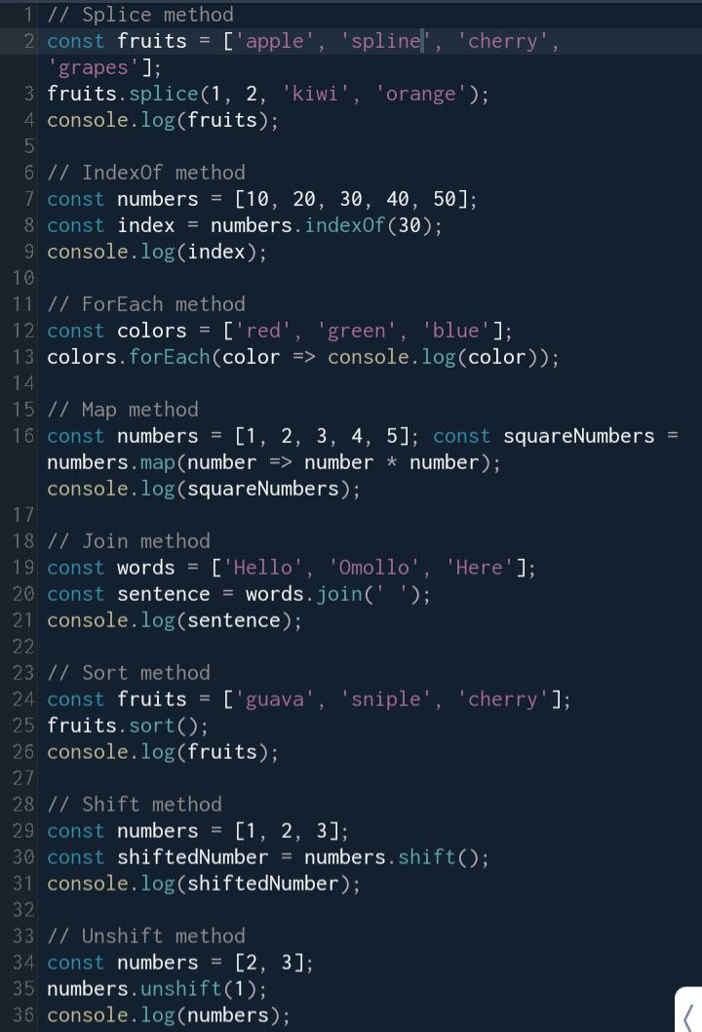Push

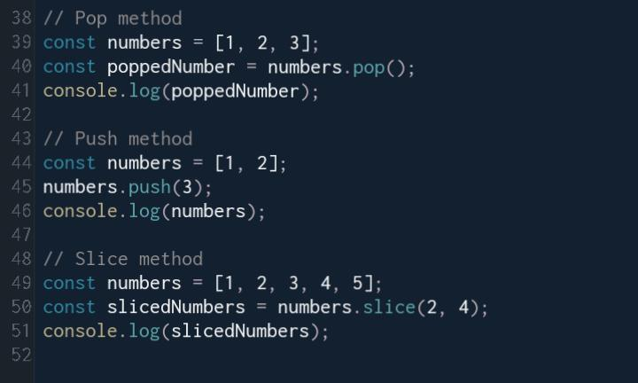

**OBJECTS IN JAVASCRIPT**

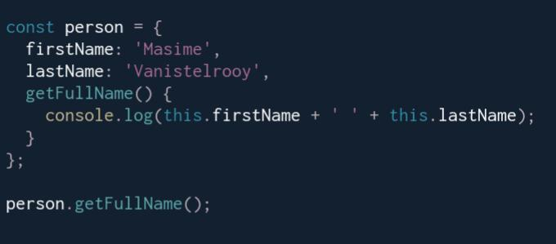**a code showing how “this” keyword is used**

**What a constructer is and a code showing its implementation**

A constructor function is a special type of function in JavaScript that is used to create new objects with the same properties and methods. To create a constructor function, we use the "function" keyword and use the "this" keyword to set the properties and methods of the object that will be created.

